**Daelink: Vaga de Emprego para pessoas com deficiência**

*Daelink: Job opportunity for people with special needs*

*Daelink: Oportunidad laboral para personas com necessidades especiales*

**Alex Expedito dos Santos**

*Alex.santos462@etec.sp.gov.br*

**Andreza Maria de Souza Rocha**

*andreza.rocha2@etec.sp.gov.br*

**Danilo Santos Soares**

*Danilo.soares31@etec.sp.gov.br*

**Endrigo Gustavo Brandão de Oliveira**

*Endrigo.oliveira2@etec.sp.gov.br*

**Jeferson Roberto de Lima**

*jerfeson.lima@etec.sp.gov.br*

|  |  |
| --- | --- |
| **Palavras-chave:**  *PWN.*  *Mercado de Trabalho.*  *Plataforma Digital.*  *Inclusão.*  **Keywords:**  *Inclusion.*  *PWN.*  *Labor Market.*  *Digital Platforms.*  **Palabras clave:**  inclusión*.*  personas con discapacidad*.*  mercado laboral*.*  plataformas digitales*.*  **Apresentado em:**  05 dezembro, 2024  **Evento:**  7º EnGeTec  **Local do evento:**  Fatec Zona Leste  **Avaliadores:**  Avaliador 1  Avaliador 2  [Desenho com traços pretos em fundo branco e letras pretas em fundo branco  Descrição gerada automaticamente com confiança média](https://creativecommons.org/licenses/by-nc-sa/4.0/) | **Resumo:**  Este trabalho aborda a inclusão de pessoas com Deficiência (PWNs) no mercado de trabalho por meio de um sistema baseado em plataformas digitais que promovem conectividade. As cotas para PWNs frequentemente não são preenchidas devido à falta de procura das empresas e ao preconceito. Embora existam ações para estabelecer cotas para PWNs, a inclusão enfrenta desafios significativos, resultando em menores taxas de participação no mercado de trabalho comparadas as de pessoas sem deficiência. O objetivo do estudo é desenvolver uma plataforma digital que promova a inclusão profissional para facilitar a integração deste público no mercado de trabalho. A metodologia empregada inclui a análise das necessidades de PWNs e empresas. Os resultados indicam a criação de um protótipo de sistema, composto por um site e um aplicativo que pode ser utilizado para empresas preencherem vagas remanescentes dentro de suas instituições. A sua construção é pensada essencialmente para empresas, consistindo em um site e aplicativo que mostram os principais candidatos para vagas remanescentes de determinadas áreas. Portanto, demonstra-se que a plataforma tem a capacidade de estabelecer uma melhor eficácia de inclusão.  **Abstract:**  This work addresses the inclusion of People with special needs (PWN) in the labor market through a system based on digital platforms that promote connectivity. Quotas for them are often not filled due to a lack of demand from companies and prejudice. Although there are actions to establish quotas for People with special needs, inclusion faces significant challenges, resulting in lower participation rates in the labor market compared to people without disabilities, the study objective is to develop a digital platform that promotes professional inclusion to facilitate the integration of PWN into the job market. The theoretical support used to include the analysis of the needs of PWN and companies. Results reveal indicate the creation of a prototype system, consisting of a website and an application that can be used by companies to fill remaining vacancies within their institutions. Its construction is essentially designed for companies that showcase the main candidates for remaining vacancies in certain areas. Therefore, the project can be qualified to enhance the inclusion of PWN in the Labor Market.  **Resumen:**  Este trabajo aborda la inclusión de las personas con discapacidad (PWN) en el mercado laboral a través de un sistema basado en plataformas digitales que fomentan la conectividad. A menudo, las plazas reservadas a personas con discapacidad no se cubren debido a la falta de demanda por parte de las empresas y a los prejuicios. Aunque existen medidas para establecer cuotas, la inclusión se enfrenta a importantes retos, lo que se traduce en menores tasas de participación en el mercado laboral en comparación con las personas sin discapacidad. El objetivo del estudio es desarrollar una plataforma digital que promueva la inclusión profesional para facilitar la integración de este colectivo en el mercado laboral. La metodología utilizada incluye el análisis de las necesidades tanto de las personas con discapacidad como de las empresas. Los resultados indican la creación de un prototipo de sistema consistente en una página web y una aplicación que pueden utilizar las empresas para cubrir vacantes en sus instituciones. Su construcción está pensada esencialmente para las empresas y consiste en una página web y una aplicación que muestran los principales candidatos para las vacantes que quedan en determinadas áreas. Así pues, se demuestra que la plataforma tiene capacidad para establecer una inclusión más eficaz. |

# Introduction

The integration of individuals with special needs (PWN) into the labor market through digital connectivity platforms represents a significant and pressing concern. Despite the existence of numerous social initiatives aimed at integrating PWNs into society at large, the number of PWNs employed in companies remains disproportionately low, as evidenced by the insufficient fulfillment of established quotas. This persistent exclusion of PWNs from the labor market underscores the continued need for more robust measures to facilitate their inclusion. (INTERNATIONAL DISABILITY ALLIANCE, 2022). Therefore, this study aims to develop a system that facilitates connectivity in a more efficient manner, utilizing web technologies and mobile applications, with the objective of enhancing the integration between companies and their PWNs.  In this context, the labor market participation and formalization rates of people with disabilities aged 14 and over are significantly lower than those of people without disabilities. The labor market participation rate of people with disabilities is 23.8%, while the formalization rate is 34.3%. In comparison, the rates for people without disabilities are 66.3% and 50.9%, respectively (IBGE, 2022). One of the primary constraints impeding the inclusion of PWNs in the labor market is prejudice. A significant number of companies remain reluctant to hire individuals with disabilities, often due to a lack of awareness about the skills and abilities these professionals possess. (CNN, 2021).

It is therefore imperative to identify solutions that facilitate the integration between companies and PWN, thereby increasing opportunities and hiring these professionals through the utilization of new technology, with the ultimate goal of promoting a more inclusive society. In light of these considerations, it becomes pertinent to inquire as to why the quotas for PWNs in the labor market remain unfulfilled and to what extent a digital platform for professionals can facilitate the integration of these individuals into companies.  The hypothesis is that the use of a digital system specifically designed to connect companies and people with disabilities can increase the filling rate in the labor market, facilitating the recruitment process and overcoming current barriers, such as prejudice. The objective of this study is to develop a digital platform that facilitates the integration of people with disabilities into the labor market, thereby promoting a more inclusive work environment and increasing the number of quota positions filled.

The initial stage involved a bibliographic review of the inclusion of PWN in the labor market, with an emphasis on inclusion studies and tools to ascertain how digital platforms can facilitate the hiring of PWN. Based on the findings of this review, we proceeded to employ a quantitative method and study case to gather all data and analyze specific problems, employing both inductive and deductive methods in accordance with the approach set forth by Lakatos and Marconi (2017). The research will address several seminal authors in the field, including CNN (2022), which analyzes the importance of using technology to enhance inclusion. The aforementioned authors will be referenced throughout the article in order to provide theoretical support for the development of the platform and its potential solutions to the inclusion problem. The development was divided into three sections: the web, the mobile application, and the recommendation system. React Vite was selected for web development due to its straightforward component creation and processing capabilities (SCHMITZ; GEORGII, 2015). React Native was employed for mobile app development due to its native and cross-platform compatibility with Android and iOS (ESCUDELARIO; PINHO, 2020). The recommendation system utilized Python for its extensive toolset, including Scikit-Learn for machine learning (MENEZES, 2014).

# Theoretical Foundation

This chapter aims to abstract all the stages of the theoretical foundation for the understanding of this article, together with the presentation of concepts and technologies. The aim is to demonstrate all the theoretical underpinnings of the DAELink platform.

## Challenges of Inclusion in the labor Market for people with disabilities

In Brazil, approximately 18.6 million Brazilians over the age of two have some type of disability, and inclusion remains a challenge due to a lack of accessibility and adequate supports systems (G1, 2023)

Highlighted by a comparatively inadequate perspective in relation to other candidates, along with challenges rooted in internalized societal prejudices that hinder adaptive processes in new circumstances, both in general and corporate environments (RIBEIRO; DELLATORRE, 2021).

According to data from the Brazilian Institute of Geography and Statistics (IBGE, 2022), individuals with disabilities face greater difficulties entering the labor market. The labor force participation rate for people with disabilities is about 28.3%, compared to 66.3% for those without disabilities, and can be seen in the figure 1.

Figure 1 – Estudo IBGE

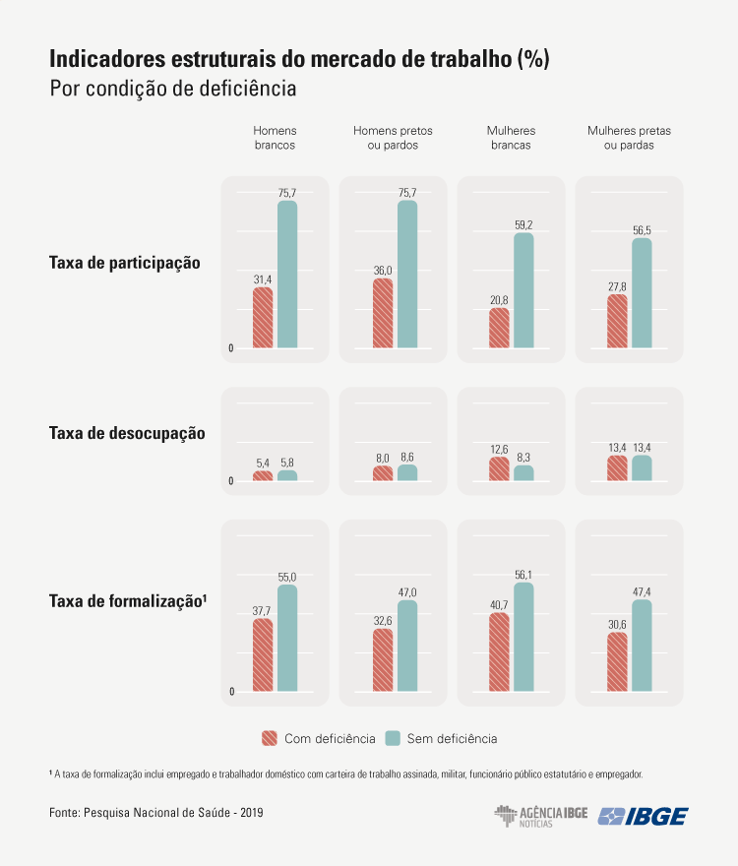

Source: IBGE (2022)

Unemployment among people with disabilities is higher than among those without disabilities, and this disparity mainly affects young people (CNN, 2022). These people also receive lower incomes, about two-thirds of the value of those without disabilities, with a higher incidence of extreme poverty, especially in sectors such as domestic services and agriculture.

* 1. Legislation and solutions for businesses and people with disabilities

The Brazil establishes that companies with one hundred employees or more are required to fill 2% to 5% with people with disabilities, known as of law quotas, according to Article 1 of Law No 8,213, of July 24, 1991:

Article 1: Social Security, by means of contributions, aims to ensure its beneficiaries indispensable means of maintenance due to incapacity, involuntary unemployment, advanced age, length of service, family burdens and imprisonment or death of those on whom they depended economically. (BRAZIL,1991)

*Art. 1º A Previdência Social, mediante contribuição, tem por fim assegurar aos seus beneficiários meios indispensáveis de manutenção, por motivo de incapacidade, desemprego involuntário, idade avançada, tempo de serviço, encargos familiares e prisão ou morte daqueles de quem dependiam economicamente. (BRASIL,1991)*.

Although the law has been in effect for around thirty years, it cannot be said to have been fully enforced due to legislative issues, such as the need for better specifications, and other challenges like the lack of professional qualification for people with disabilities (SANTOS NETO, 2020).

In the contemporary, an increasing number of companies are recognizing the substantial advantages associated with the inclusion of disabled workers who are fully engaged, possess remarkable talent, and demonstrate remarkable work ethic. Consequently, organizations are implementing proactive measures to actively recruit and hire individuals with disabilities with the objective of reducing turnover, enhancing revenue and profitability (WINIARSKI, 2024). This is due to the lack of an accessible system, which generates a gap in the connection between People with especial needs. Therefore, there is a need to create a system for this digital integration. The solution for a digital connectivity platform can promote social inclusion and improve these people.

* 1. DaeLink system for companies to fill their vacancies for people with special needs

The project is based on the creation of system for web and mobile application, based on JavaScript languages and with a cloud database, that allows business users to connect in a simplified way, and thus fill their vacancies, through recommendation system, and chat, and the availability of vacancies. To achieve this, the tools described below were used.

Figure 2 – Process page website

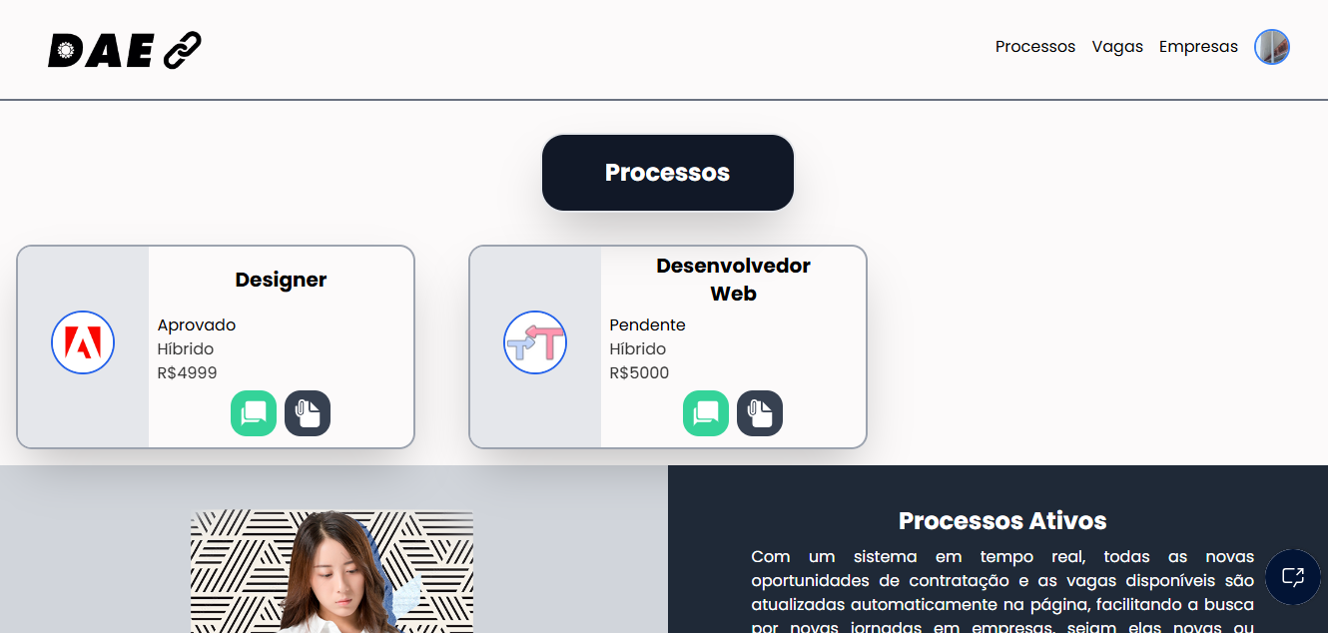

Fonte: self-authored (2024)

## React Vite

React is a library in JavaScript used for creating interface in a partitioned manner, which can be combined into components.  Ranging from websites to mobile applications (REACT).

Designed to simplify and speed up the creation of interfaces, it was created by Jordan Walke, an engineer at Facebook, in 2011. It has now become the most popular JavaScript library (SILVA, 2021).

Vite comes from the French meaning “fast” as demonstrated in its proposal to be a tool that allows the creation of front-end projects in an accessible way, being light and practical, bringing creative concepts to a web pages (VITE).

* 1. React Native

React Native is a platform based on React, enabling the creation of hybrid applications, running on IOS (apple) and Android, being created by Facebook in 2013 (ESCUDELARIO; PINHO, 2020). React Native can be defined as an open-source framework that aims to create native applications, that is, there is a web layer as an interface, but the native application itself (CASA GRANDE, C., & TANAKA, S. 2023).

* 1. Expo

Expo, along with React’s create-react-app package, provides the necessary structure to develop an application, offering an environment that simplifies the creation of mobile applications (ESCUDELARIO; PINHO, 2020). Expo is a tool used in mobile development with React Native that allows easy access to some native APIs without needing to install additional dependencies or modify native code (ROCKETSEAT, 2020). This makes the development process faster and more accessible for developers.

* 1. Python

Python is an extremely efficient programming language due to fact that programs constrain Dewar lines of code, helping to build “clean” code, obtaining a quick understanding and debugging (MATTHERS, 2016).

Python often requires additional packages that are not included in the Anaconda distribution. One such package manager is pip, a tool that manages and installs Python packages (MCKINNEY, 2018). In this sense, there are two types: Conda and pip both serve different purposes, Conda provides general package management for a wide variety of languages in the Conda environment, and pip offers services specifically for python (MUELLER, 2020).

* 1. Machine Learning

Machine Learning uses data filtering to create new information, generating significant results, enabling intelligent decision-making through the data generated, (KNEUSEL, 2024). Technology is constantly evolving, and machine learning becomes crucial for the advancement of various commercial areas, being adopted by today´s largest companies such as Netflix (DOMINGOS, 2017).

* 1. Firebase

Firebase Database is an effective tool for database creation, working through a real-time data update, and cloud-based storage. These features allow multi-platform projects with an efficient performance while offering compatibility to other Google Systems (FIREBASE).

* 1. UML

The Unified Modeling Language is a visual representation to use to help to understand the system in its logical part, being an accepted international standard for software (GUEDES, 2018).

Used to carry out a complete project, it needs to be able to be changed later and allow a better understanding between customers and developers (PEREIRA, 2011). In general terms, through the diagrams that make up the UML, the entire project is approached in different technical ways to obtain a better result in its completion (GUEDES, 2018).

# Methodology

For the construction of the project, various methodologies were used for a better elaboration of the work, to analyze crucial points in relation to people with special needs in the job market and the role of the company. Accordingly, with the out by GIL (2002). The bibliographic surveys and case study together with quantitative research allow for a comprehensive understanding of the subject.

The Quantitative study is a method used to analyze a problem with data and statistics. In accordance with relevance of quantitative data to understand the distribution of opportunities (PEREIRA et al, 2018). By employing this method, we seek to analyze patterns, identify statics and the impact of the inclusion of people with special needs in the job market.

The case study is a methodological process direct to an in-depth for an analyze of the specific phenomenon generating the examine of its multiple's dimensions along with associated factors, with the aim of identify the root causes of a give problem (GIL, 2017). This type of study is extremely important for clarifying typical issues in the areas of research and practice and is utilized for investigative the discrepancy in the job market experienced by people with special needs helping to identify the principles that contribute to this inequality (GIL, 2002).

Finally, bibliography allows a conceptual and theoretical analysis of a given theme using articles and other pertinent materials and bibliographic sources, (GIL, 2017). This methodology is used to examine the notable perspective of researchers in the field, with the aim of elucidating the members of the job market and their interconnection with individuals with special needs.

## Technology Use

In regard to the formatting and development of the project, the technologies mentioned in the preceding chapter are utilized, with each tool being of significant importance due to its efficacy in the construction of the system. React has been utilized as a library for the development of the user interface, in conjunction with integration with the Firebase database.

Figure 3 – Home Page DaeLink website

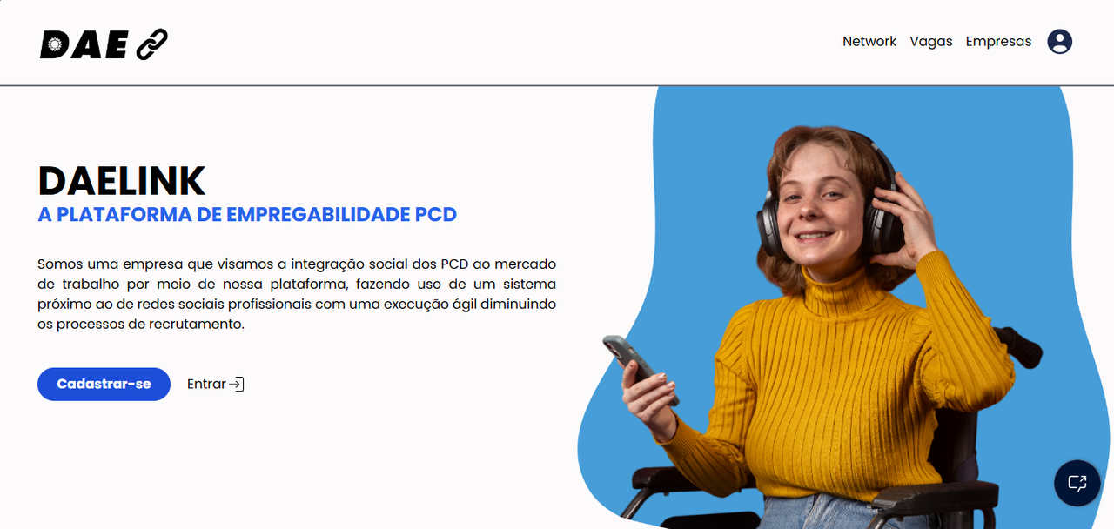

Source: self-authored (2024)

Python was employed in conjunction with machine learning for the purpose of development. The DaeLink recommendation system. The system enables companies to efficiently and automatically identify individuals with disabilities who are registered on the platform.

Figure 4 – Screen and terminal on system recommendation

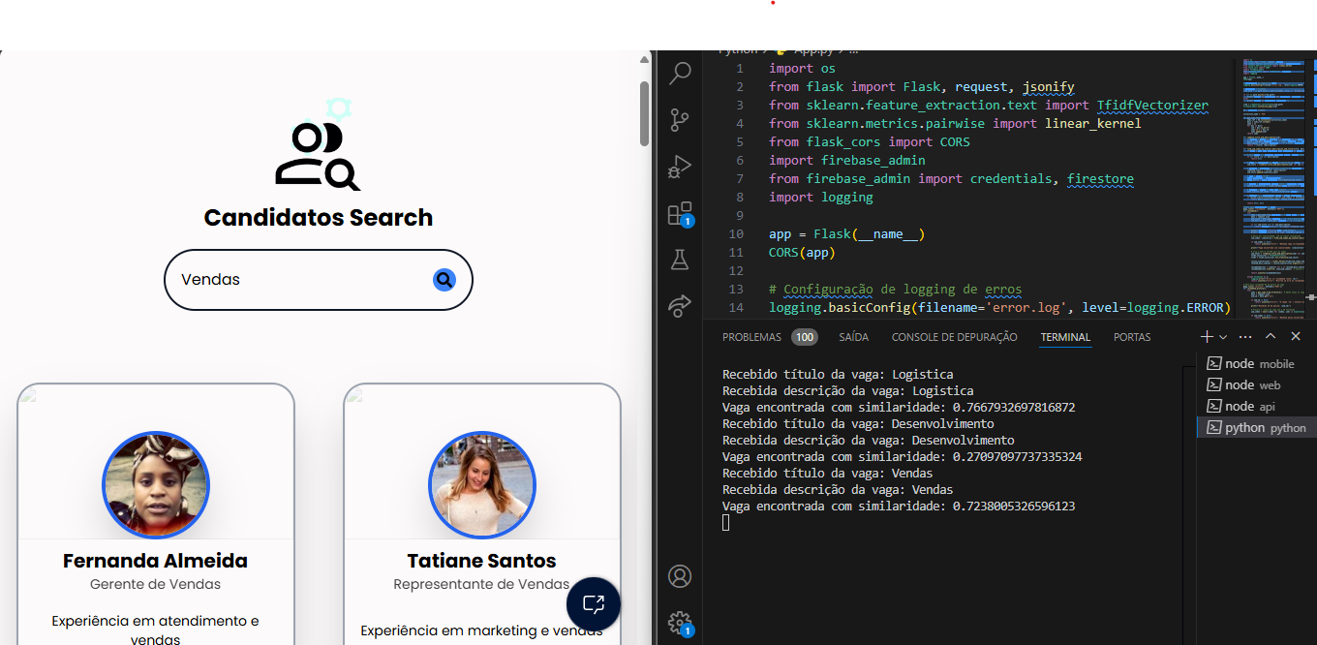

Fonte: self-authored (2024)

In the domain of mobile development, we utilize React Native in conjunction with Expo and Firebase, thereby enabling the application to provide access for both web and mobile platforms. The mobile application has been designed with the specific needs of people with disabilities in mind. It enables them to view and manage the vacancies for which they have applied.

Figure 5 – Home page mobile

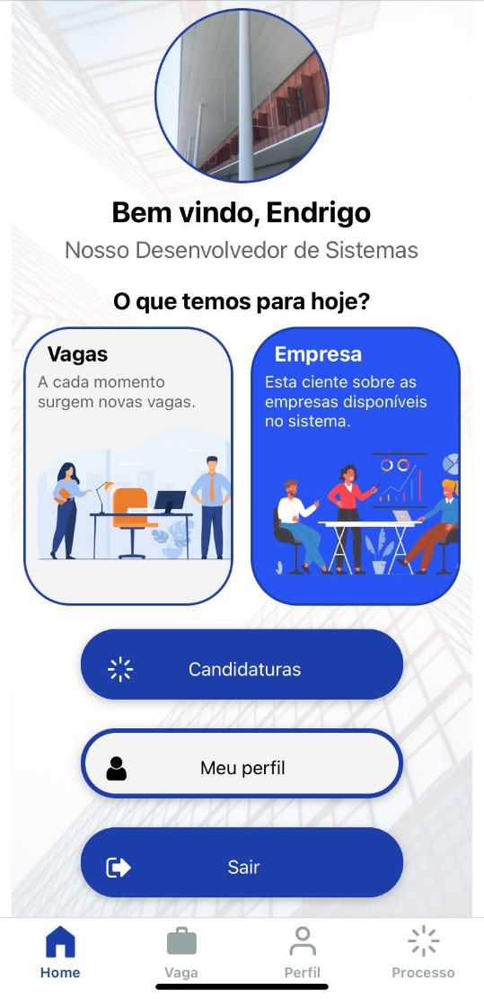

Fonte: self-authored (2024)

The use of the Unified Modelling Language (UML) was instrumental in the system's planning phase, enabling its projection through the use of various diagrams, including use case, sequence, activity, and state machines. The aforementioned diagrams were of significant value in facilitating the organization and execution of the project in a clear and structured manner.

In addition to the aforementioned technologies, the project methodology was based on the approach proposed by Lakatos and Marconi (2017). The method provides a systematic approach to defining objectives, problem statements, and methods. This approach facilitated the organization of the DaeLink development process, integrating quantitative and qualitative analysis to address the challenges faced by individuals with disabilities in the job market.

# Results and discussions

During the development phase of Daelink, some limitations and challenges were identified regarding the satisfaction with accessible and practical functionality. Through technology, the project aimed to simplify the hiring process, making it easily accessible and adaptable to various needs. The main points of discussion were the social and legal aspects of ensuring compliance with these areas. Consequently, the project came to life as an integrated system for managing candidate information and resources to streamline the hiring process. It was developed using React Vanilla for the web page and React Native for the app, with Firebase as the data storage system. Python and other technologies were also used, forming the foundation for the project’s unique intelligent recommendation system. By consensus, the group considered Daelink a project that provided significant learning in development and research on social accessibility in the digital sphere.

The project holds particular importance in relation to social inclusion in the job market, addressing significant gaps in access to professional opportunities for people with disabilities (PWN). By offering a platform that centralizes information and simplifies the inclusion process, Daelink seeks to meet the growing need for practical, accessible solutions that promote professional inclusion for people with disabilities.

## Prototype Daelink

Throughout the creation of the Daelink prototype, analyzing the challenges faced by companies when hiring people with disabilities (PWN) became essential. This analysis highlighted the need for an integrated candidate information system that could streamline the professional inclusion process for these individuals. With this idea as a foundation, the project was developed with the goal of making the hiring process more practical and efficient, conforming to legal and social standards, while also providing a resource that exemplifies this dynamic. The following image shows an example of the project layout, illustrating job listings where candidates can apply and enter the hiring process.

**4.2 Project Daelink**

Conceived with the goal of addressing the unique needs of each user, this project aims to cater to individual requirements by providing distinct resources and functionalities. For people with disabilities (PWD), it offers straightforward tools, ranging from viewing companies and available jobs to managing crucial steps in the hiring process, such as uploading and adjusting documents and diplomas to match job requirements, updating personal and professional information, tracking application status, and communicating with the company in case of any issues or to schedule meetings. On the business side, companies have access to resources aligned with those of the PWD. Managers can oversee recruitment processes, identify suitable candidates, communicate privately with PWD applicants, and use the intelligent recommendation system to streamline the search for ideal candidates. Externally, an administrator is responsible for supervising and organizing candidate and company information, ensuring optimal system performance and compliance with inclusion standards.

# Final Consideration

Over the course of the project, meaningful results were achieved that contribute to the advancement of inclusion. The project was designed to automate and facilitate the filing of remaining job positions for people with special needs, promoting greater inclusion of people with special needs (PWN) in the job market.

Through a detailed analysis of the main barriers faced by both companies and PWN, it was possible to develop an innovative solution that not only connects these two groups, but also optimizes the hiring process based on legal, social and accessibility criteria.

Brazilian laws have a great responsibility when it comes to social inclusion, but in the course of developing research on the subject, a lack of enforcement of these laws can be seen, creating a huge gap in the labor market, another aggravating factor of the situation is the society itself, which is still adapting to the inclusion of all, but still there are several points to improve, and a project like this becomes crucial for the future.

DaeLink differentiates itself by integrating an inclusive digital environment that facilitates the lives of PWNs, offering an adapted platform for documents submission and job application tracking, while also benefiting companies by streamlining the selection process with vacancy management tools and a candidate recommendation system. Despite the challenges faced, such as studying various technologies for development, the solutions proved effective, allowing for progress in achieving the established goals.

DaeLink, therefore, has the potential to transform the landscape of social and professional inclusion, directly contributing to increasing the participation of disabled people in the job market and encouraging companies to adopt more inclusive practices and contribute to a more equal world. In the future, DaeLink could be expanded and adapted in partnership with public policies, extending its reach to regions with less access to digital resources and facilitating the development of training programs aimed at the digital inclusion of people with disabilities.

**Referências**

DOMINGOS, Pedro. ***O Algoritmo Mestre***: ***como a busca pelo algoritmo de machine learning definitivo recriará nosso mundo***. São Paulo: Novatec, 2017. 344 p.

ESCUDELARIO, Bruna de Freitas; PINHO, Diego Martins de. React Native: ***desenvolvimento de aplicativos mobile com react***. São Paulo, Sp-Brasil: Casa do Código, 2020. 189 p.

GIL, A. C. **Como elaborar projetos de pesquisa**. [s.l.] São Paulo Atlas, 2002. 175p.

GUEDES, Gilleanes T. A. **UML 2**: uma abordagem prática. 3. ed. São Paulo: Novatec Editora, 2018. 496 p.

KNEUSEL, Ronald T.***Como a Inteligência Artificial Funciona***: da magia à ciência. São Paulo: Novatec Editora Ltda, 2024. 256 p.

LAKATOS, Eva Maria; MARCONI, ***Marina de Andrade. Fundamentos de Metodologia Científica***. 8. ed. São Paulo: Atlas, 2017. 368 p.

SANTOS NETO. **Difícil inserção de pessoas com deficiência no mercado de trabalho**. Campinas, 23 set. 2020. Available at: https://unicamp.br/unicamp/ju/noticias/2020/09/23/dificil-insercao-de-pessoas-com-deficiencia-no-mercado-de-trabalho/. Accessed on: 17 set. 2024.

WINIARSKI, Diane. **How People With Disabilities Make A Positive Impact In The Workplace.** 2024. Disponível em: https://www.forbes.com/sites/dianewiniarski/2024/01/30/how-people-with-disabilities-make-a-positive-impact-in-the-workplace/. Acessed on: 19 out. 2024.

MATTHERS, Eric. **Curso intensivo de python**: uma introdução prática e baseada em projetos à programação. São Paulo, Sp-Brasil: Novatec Editora, 2016. 656 p.

MCKINNEY, Wes. **Python para análise de dados: tratamento de dados com pandas, numpy e ipython. São Paulo: Novatec Editora, 2018. 616 p.**

MENEZES, Nilo Ney Coutinho. **Introdução à Programação com Python**: algoritmos e lógica de programação para iniciantes. 2. ed. São Paulo, Sp-Brasil: Novatec Editora, 2014. 328 p.

MENEZES, Nilo Ney Coutinho. **Introdução à Programação com Python: algoritmos e lógica de programação para iniciantes.** 3. ed. São Paulo, Sp-Brasil: Novatec Editora, 2019. 328 p.

MUELLER, John Paul. **Começando a Programar em Python**: para leigos. 2. ed. Rio de Janeiro Rj-Brasil: Alta Books, 2020. 391 p.

PEREIRA, Adriana Soares et al. **Metodologia da pesquisa científica.** 2018. 119p.

PEREIRA, Luiz Antônio Demoraes. **Análise e Modelagem de Sistemas com a UML**: com dicas e exercícios resolvidos. Rio de Janeiro: Edição do Autor, 2011. 282 p.

SCHMITZ, Daniel; GEORGII, Daniel Pedrinha. **React - Guia do Iniciate**: domine a biblioteca javascript utilizada pelo facebook e instagram. São Paulo: Leanpub, 2015. 51 p.

SILVA, Mauricio Samy.***React Aprenda Praticando*: desenvolva aplicações web reais com uso da biblioteca react e de seus módulos auxiliares. São Paulo: Novatec Editora Ltda, 2021. 240 p.**

BRAZIL. Lei nº 8.213, de 24 de julho de 1991. Dispõe sobre os planos de benefícios da previdência social e dá outras providências. **Da Finalidade e dos Princípios Básicos da Previdência Social.** Available at: https://www.planalto.gov.br/ccivil_03/leis/l8213cons.htm. Accessed on: 07 jun 2024.

Casa Grande, C., & Tanaka, S. (2023). Comparação entre o desempenho de aplicações para smartphones  
desenvolvidas em flutter e react native: **uma análise utilizando algoritmos de ordenação**. Revista Terra  
& Cultura: Cadernos De Ensino E Pesquisa, 39(especial), 7-17. Recuperado  
de http://periodicos.unifil.br/index.php/Revistateste/article/view/2796/2559 Accessed on: 05 maio 2024.

CNN Brasil. **IBGE divulga estudo inédito sobre deficiência e desigualdades sociais no Brasil**: Pesquisa revela estatísticas sobre inserção no mercado de trabalho, perfis de renda, acesso à educação e serviços de saúde, além de características sobre moradia de pessoas com deficiência. São Paulo, 21 set. 2022. Available at: https://www.cnnbrasil.com.br/nacional/ibge-divulga-estudo-inedito-sobre-deficiencia-e-desigualdades-sociais-no-brasil/. Accessed on: 04 jul. 2024.

CNN Brasil**. Lei de cotas para pessoas com deficiência faz 30 anos neste sábado**. 2021. Disponível em: https://www.cnnbrasil.com.br/nacional/lei-de-cotas-para-pessoas-com-deficiencia-faz-30-anos-neste-sabado/. Accessed on: 15 jun. 2024.

FIREBASE. **Aprenda os fundamentos.** [S.I]. Firebase, 2024. Available at: https://firebase.google.com/docs?hl=pt-br&_gl=1*18pchen*_up*MQ.&gclid=504d29a01bc01aa2d6394f92b0c2ad51&gclsrc=3p.ds. Accessed on 07 jun 2024.

G1. **Brasil tem 18,6 milhões de pessoas com deficiência, cerca de 8,9% da população**, segundo IBGE. 2023. Available at: https://g1.globo.com/economia/noticia/2023/07/07/brasil-tem-186-milhoes-de-pessoas-com-deficiencia-cerca-de-89percent-da-populacao-segundo-ibge.ghtml. Accessed on: 14 maio 2024.

INTERNATIONAL DISABILITY ALLIANCE. Equalizing Access to the Labour Market. [S.I.], 2022. Available at:https://www.internationaldisabilityalliance.org/sites/default/files/ida_equalizing_access_to_the_labour_market.pdf. Accessed on: 26 september. 2024.

IBGE **- Desemprego e informalidade são maiores entre as pessoas com deficiência | Agência de Notícias,** 24 out 2022. Disponível em: https://agenciadenoticias.ibge.gov.br/agencia-noticias/2012-agencia-de-noticias/noticias/34977-desemprego-e-informalidade-sao-maiores-entre-as-pessoas-com-deficiencia. Accessed on: 15 maio 2024.

IBGE – **Instituto Brasileiro de Geografia e Estatística. Desemprego e informalidade são maiores entre as pessoas com deficiência.** Agência de Notícias IBGE, 22 nov. 2022. Disponível em: https://agenciadenoticias.ibge.gov.br/agencia-noticias/2012-agencia-de-noticias/noticias/34977-desemprego-e-informalidade-sao-maiores-entre-as-pessoas-com-deficiencia. Accessed on: 15 maio 2024.

REACT. **Introdução** [S.I], React, 2024. Disponível em: https://pt-br.legacy.reactjs.org/docs/getting-started.html. Acessado em: 07 jun 2024.

VITE. **Visão geral** [S.I], React vite, 2024. Disponivel em: https://pt.vitejs.dev/guide/. Acessado em: 07 jun 2024.

RIBEIRO, L.; PINHEIRO, S.; DELLATORRE, DESAFIOS **DA INCLUSÃO DE PESSOAS COM DEFICIÊNCIA NO MERCADO DE TRABALHO: UM ESTUDO SOBRE A PERCEPÇÃO DOS ENVOLVIDOS The challenges of including people with disabilities into the labor market: a study on the perception of those involved,** 2015. Disponível em: https://www.uricer.edu.br/site/pdfs/perspectiva/148_537.pdf.

ROCKETSEAT. **Expo e React Native**: a união que está transformando o desenvolvimento mobile. Blog Rocketseat, 09 out. 2020. Disponível em: https://blog.rocketseat.com.br/expo-react-native/. Acesso em: 09 jun. 2024.